Power Electronics

Maximum Power Point Tracking

Hyunui Park & Gyeonheal An

06/17/23

**Abstract - The final project focuses on Maximum Power Point Tracking (MPPT) for solar panels. As solar irradiance fluctuates, the current and voltage output from the solar panel vary, resulting in changes in the power output. However, to minimize power losses, it is necessary to track the maximum power point and optimize power transmission. There are two main types of MPPT algorithms: Perturb and Observe (P&O) and Incremental Conductance (INC). In this report, we conducted experiments by selecting and comparing coefficients in the algorithm code to reduce the oscillation losses associated with the P&O algorithm. As a result, it was observed that selecting suitable coefficients tailored to the weather conditions and environment can effectively reduce power losses.**

# Introduction

I

n recent years, global agreements aimed at protecting the environment and promoting sustainable development have been established. As a result, solar energy, an infinite source of energy that does not emit pollutants, has gained prominence as a new energy source. Solar panels are constructed based on solar cells, which are diodes that generate electric current when exposed to light. The current-voltage characteristics of these solar cells exhibit a relationship where the voltage decreases as the current increases, and the current decreases as the voltage increases. Therefore, to achieve the highest efficiency, it is necessary to find the maximum point in the current and voltage values that vary with the amount of solar radiation and supply power accordingly. The objective of this experiment was to compare previously developed algorithms, identify their limitations, and develop a more efficient Maximum Power Point Tracking (MPPT) algorithm.



**Figure 1. Solar Energy System**

# Understanding MPPT Principles

1) Modeling of Solar Cell

To find the maximum power point of the current and voltage generated by solar cells, it is necessary to first model the solar cell mathematically. There are two main approaches to choose solar cells.

First is the physical model of a solar cell.

**Figure 2-1. Equivalent Circuit of Single Solar Cell**

This physical model is generally expressed by the following equation:

$$I_{PV}= I_{PH}-I_{sat}\left[e^{\left(\frac{V+IR_{s}}{k_{0}}\right)}-1\right]-\frac{V+IR_{s}}{R_{sh}}$$

If the solar-cell has connected with serial-parallel

**Figure 2-2. Equivalent Circuit of Serial-Parallel Solar Cell**

This physical model is generally expressed by the following equation:

$$I_{sa}=N_{p} I_{ph}-N_{p}I_{sat}\left[e^{\left(\frac{V_{sa}}{N_{s}k_{0}}+\frac{I_{sa}R_{s}}{N_{p} k_{0}}\right)}-1\right]-\frac{1}{R_{sh}}(\frac{V_{sa}}{N_{s}}+\frac{I_{sa}R_{s}}{N_{p}})$$

Second is the functional model of a solar module that can be described through the current-voltage (I-V) curve, which represents the relationship between the module's output current and voltage.

A solar module consists of multiple solar cells connected in series or parallel. Series connection increases the voltage, while parallel connection increases the current. The I-V curve captures the characteristics of the module's performance under different operating conditions.

The optimal operating point in the I-V curve is the point where the product of current and voltage is maximized, known as the Maximum Power Point (MPP). At this point, the module provides the maximum power output, maximizing the efficiency of the solar system. Designing and operating the module to operate at the MPP requires employing Maximum Power Point Tracking (MPPT) algorithms to dynamically adjust the current and voltage, ensuring the system operates at its peak performance.

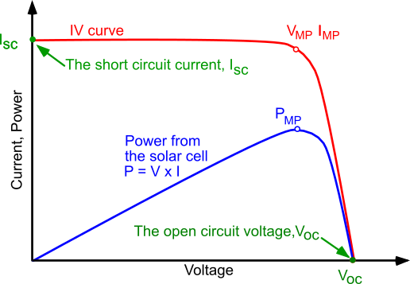

**Figure 2-3. Functional model of Solar Cell**

2) Principle of Maximum Power Point Tracking

Weather is not constant and undergoes continuous fluctuations. This means that solar irradiance also varies, leading to changes in the current and voltage generated by solar cells. Consequently, it is necessary to track the maximum points of current and voltage to find the maximum power point.

**Figure 2-4. Fluctuations of the maximum power point**

In Figure 4. We can see observe changes in the maximum power point (MPP) due to fluctuations in current and voltage.

**Figure 2-5. V-P Characteristics Graph**

**Figure 2-6. Tracking Operation of MPPT**

When observing the V-P characteristic curve in Figure 5, at the maximum power point, the rate of change of the slope becomes zero. Using this principle as a reference, we estimate that to the left of the maximum power point, the slope is greater than zero, and to the right, it is less than zero. In actual tracking operations, when we refer to Figure 6, if the measured power is located to the left of the maximum power point, the converter increases the power. Conversely, if the measured power is located to the right of the maximum power point, the converter decreases the power.

3) MPPT Algorithm

There are two commonly used methods in MPPT (Maximum Power Point Tracking) algorithms: the P&O (Perturb and Observe) algorithm and the INC (Incremental Conductance) algorithm.

1.P&O Algorithm

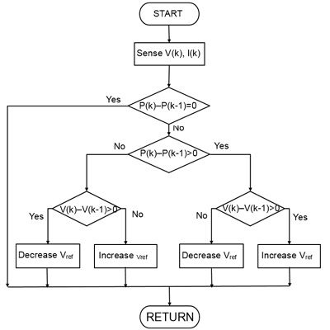

**Figure 2-7. Flow Chart of P&O Algorithm**

The P&O (Perturb and Observe) algorithm, as can be seen in Figure 7, has a simple structure. It operates with two comparisons and one operation, which is advantageous. However, it has the drawback of generating oscillations as it approaches the maximum power point.

2. INC Algorithm

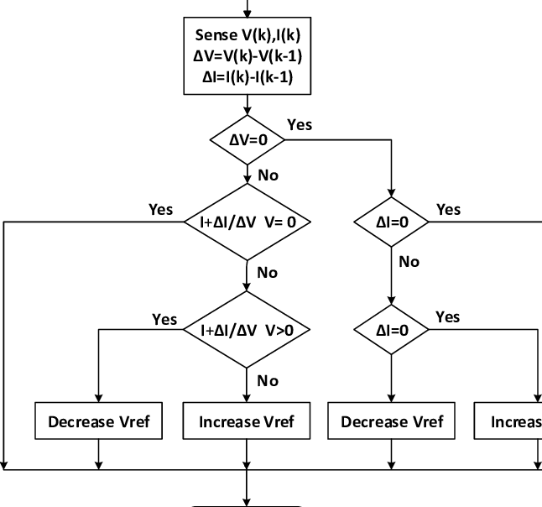

**Figure 2-8. Flow Chart of INC Algorithm**

The INC (Incremental Conductance) algorithm offers advantages such as excellent responsiveness in rapidly changing conditions, accurate estimation of the maximum power point, and overall stability. However, it does have the drawback of increased complexity in its implementation.

# Analysis of **P&O Algorithm**

The objective of this experiment was to observe the behavior of MPPT based on the given data of solar irradiance and temperature over a day. The focus was to understand the actual tracking operation of MPPT and identify areas for improvement.

1. Data of Solar radiation & temperature

Using Matlab to plot the data.



**Figure 3-1. 2022.01.01 Solar Data**



**Figure 3-2. 2022.01.01 Temperature Data**



**Figure 3-3. 2022.03.16 Solar Data**



**Figure 3-4. 2022.03.16 Temperature Data** 

**Figure 3-5. 2022.06.28 Solar Data**



**Figure 3-6. 2022.06.28 Temperature Data**



**Figure 3-7. 2022.08.10 Solar Data** 

**Figure 3-8. 2022.08.10 Temperature Data**

 **Figure 3-9. 2022.11.15 Solar Data** 

**Figure 3-10. 2022.11.15 Temperature Data**

The following are the results of tracking the Maximum Power Point using the P&O algorithm based on the provided weather data.

**Figure 3-11. 2022.01.01 MPPT**

**Figure 3-12. 2022.03.16 MPPT**

**Figure 3-13. 2022.6.28 MPPT**

**Figure 3-14. 2022.08.10 MPPT**

**Figure 3-15. 2022.11.15 MPPT**

The observations from Figures 11-15 reveal that when there are rapid fluctuations in solar irradiance (weather conditions), the tracking performance of the P&O algorithm is compromised. It was observed that the P&O algorithm exhibited weak tracking capabilities in situations of sudden changes, as mentioned earlier.

2. Oscillation of P&O Algorithm

One of the identified issues with the P&O algorithm is the occurrence of oscillations, which can be attributed to a fixed step size. When the algorithm approaches the vicinity of the maximum power point, it performs calculations in the neighboring regions on both sides, leading to oscillations. To verify this, the step size was varied from 1 to 10, and the results were observed.

**Figure 3-16. DV = 1 P&O Algorithm**

**Figure 3-17. DV = 3 P&O Algorithm**

**Figure 3-18. DV = 8 P&O Algorithm**

**Figure 3-19. DV = 10 P&O Algorithm**

As the step size (DV) increases, the computational speed improves, but larger oscillations occur. Therefore, in our research, we aimed to increase accuracy by reducing the step size value when approaching the maximum power point.

# New Algorithm Simulation

To address the problems that occur in the P&O algorithm, we have applied the principle of Incremental Conductance. $G=\frac{I}{V}$ and $∆G=\frac{∆I}{∆V}$. This value is positive on the left side and negative on the right side of the maximum power point. This system has the advantage of quickly tracking changes in irradiance by utilizing the rate of change of current and voltage. In Figure 4-1, there is a skip operation when $\frac{dP}{dV}, dV, dI$ are equal to 0. This is done to dampen the oscillations that occur during tracking. However, it is rare for the change to be exactly 0. Therefore, approximate values, $α,β,γ$ are found and applied to approximate the rate of change for each parameter to be close to 0.

**Figure 4-1. Flow Chart of New Algorithm**

The selected coefficients based on the measured data range from to .

**Figure 4-2. ,**

**Figure 4-3. ,**

**Figure 4-4. ,**

**Figure 4-5. ,**

**Figure 4-6. $α={10}^{-6},$ $β={10}^{-6}$, $γ={10}^{-6}$**

|  |  |
| --- | --- |
| Coefficient | Error |
| $α={10}^{-2},$ $β={10}^{-2}$, $γ={10}^{-2}$ | 1.0633e+04 |
| $α={10}^{-3},$ $β={10}^{-3}$, $γ={10}^{-3}$ | 7.4374e+03 |
| ${α=10}^{-4},$ $β={10}^{-4}$, $γ={10}^{-4}$ | 6.054e+03 |
| $α={10}^{-5},$ $β={10}^{-5}$, $γ={10}^{-5}$ | 6.0546e+03 |
| $α={10}^{-6},$ $β={10}^{-6}$, $γ={10}^{-6}$ | 7.3679e+03 |

**Table1. Error Calculation based on Coefficient.**

|  |  |  |  |  |
| --- | --- | --- | --- | --- |
| $$α$$ $$β$$ $$γ$$ | $$10^{-4}$$**1 $0^{-4}$ $${10}^{-4}$$** | $${10}^{-2}$$ $${10}^{-2}$$ $${10}^{-2}$$ | $${10}^{-4}$$ $${10}^{-2}$$ $${10}^{-4}$$ | $${10}^{-2}$$ $${10}^{-4}$$ $${10}^{-2}$$ |
| **Oscillation damping** | Low | High | Low | High |
| **Response to sudden solar radiation** | High | Mid | High | Low |
| **stability** | High | Low | High | High |

**Table 2. Performance analysis according to coefficient values**

The lower the $α$, the higher the stability.The smaller the $β$, the lower the vibration, and the smaller the $γ$, the better it copes with changes in solar radiation.

As evident from Table 1, it can be observed that the loss is minimized when the coefficient is at ${10}^{-4}$. Based on this, we will select the coefficients that are most suitable for the weather conditions by combining them with the data from 01/01.

**Figure 4-7. ,**

**Figure 4-8. ,**

**Figure 4-9. $α={10}^{-4},$ $β={10}^{-2}$, $γ={10}^{-2}$**

|  |  |
| --- | --- |
| Coefficient | Error |
| $α={10}^{-4},$ $β={10}^{-2}$, $γ={10}^{-4}$ | 6.0514e+03 |
| $α={10}^{-4},$ $β={10}^{-4}$, $γ={10}^{-2}$ | 6.9060e+03 |
| $α={10}^{-4},$ $β={10}^{-2}$, $γ={10}^{-2}$ | 6.9056e+03 |

**Table3. Error Calculation based on Coefficient 01/01**

Based on the data obtained on 01/01, it is anticipated that selecting appropriate coefficients for different weather conditions can reduce the loss values. The following results compare the losses by selecting coefficients for different weather conditions.

**Figure 4-10. , 03/16**

**Figure 4-11. , 03/16**

**Figure 4-12. Oscillation compared by Coefficients.**

On the left side is the P&O algorithm, and on the right side is the new algorithm. By varying the coefficients and applying them, we can observe a reduction in small oscillations.

**Figure 4-12. , 06/28**

**Figure 4-13. , 06/28**

**Figure 4-14. , 08/10**

**Figure 4-15. , 08/10**

**Figure 4-16. , 11/15**

**Figure 4-17. $α={10}^{-4},$ $β={10}^{-2}$, $γ={10}^{-4}$ 11/15**

|  |  |  |  |
| --- | --- | --- | --- |
|  | **P&O** | **NEW** | **Error** |
| **03/16** | 2.24478e+03 | 2.2166e+03 | (28.18) |
| 2.24478e+03 | 2.2448e+03 | (-0.02) |
| **06/28** | 1.1636e+04 | 1.1358e+04 | (27.8) |
| 1.1636e+04 | 1.1632e+04 | (0.4) |
| **08/10** | 5.4183e+03 | 1.1689e+04 | (overshoot) |
| 5.4183e+03 | 5.4163e+03 | (2) |
| **11/15** | 1.3925e+03 | 1.3920e+03 | (0.5) |
| 1.3925e+03 | 1.3919e+03 | (0.6) |

**Table 4. Error Calculation of Weather Data**

Based on the data, we select coefficients appropriate for each season. In seasons with significant variations in solar radiation such as spring and autumn, the values of $α$ and $γ$ should be small, while $β$ should be large. On the other hand, in summer or winter, $α$ and $β$ should be small, while $γ$ should be large.

# CONCLUSION

The goals of this experiment were twofold. Firstly, to reduce the oscillation issues and resulting losses in the P&O algorithm, and to improve the tracking accuracy. In the newly proposed algorithm, the coefficients, namely $α,$ $β, γ$ which determine the system's decision on increasing or decreasing the operating point, theoretically have a reference point of 0. However, it is difficult to achieve an exact value of 0 in practical systems. Therefore, approximate values close to 0 were selected. Among these approximate values, multiple magnitudes were compared to determine the most suitable coefficient value for different weather conditions or rapidly changing situations. Experimental results confirmed the reduction in ripple and losses. Currently, the coefficient values were selected based on data analysis, but there is a need to develop an algorithm to dynamically determine the appropriate coefficient values for real-time system adaptation.

# WORK DISTRIBUTION

|  |  |  |
| --- | --- | --- |
|  | Hyun ui | Gyeon heal |
| Algorithm Construction | 50% | 50% |
| PSIM Testing | 40% | 60% |
| Report | 60% | 40% |

# APPENDIX

|  |  |
| --- | --- |
| $$k_{0}=\frac{AKT}{q}$$ |  |
| $$I,V$$ | cell output current and voltage |
| $$I_{ph}$$ | light generated current |
| $$I_{sat}$$ | cell reverse saturation current |
| $$A$$ | ideality factors: 1 |
| $$K$$ | Boltzmann’s constant: $1.3805×{10}^{-3}[Nm/K]$ |
| $$T$$ | cell temperature in $℃$ |
| $$q$$ | electronic charge: $1.6×{10}^{-9}[C]$ |
| $$R_{s}$$ | series resistance |
| $$R_{sh}$$ | shunt resistance |

**Table 5. Modeling unit of Solar Cell**

|  |  |
| --- | --- |
| Date | Error |
| 01/01 | 7.3676e+03 |
| 03/16 | 4.3010e+03 |
| 06/28 | 6.5955e+03 |
| 08/10 | 8.7902e+03 |
| 11/15 | 1.4313e+03 |

**Table 6. Error Calculation of Weather Data**

# REFERENCE

1. A Novel Voltage Control MPPT Algorithm using Variable Step Size based on P&O Method, Jichan Kim and Hanju Cha

2. Improved adaptive step size P&O MPPT algorithm for Solar Photovoltaic System InGwon Jo, Kwanghee Nam

3. General review and classification of different MPPT Techniques Nabil Karamia,, Nazih Moubayedb , Rachid Outbib

4. A Suggestion of New Algorithm in PV System, kyungsoo Lee, Youngseok Jeong, Junghun So, Gwingjong Yu, and jaeho Choi